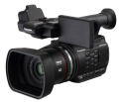



* Design icons
* History of product design
* Designers talking
* The design process
* Drawing guidelines
* Drawing in 3 dimensions
* Structures
* Bridge project
* Cogs and gears
* Cams
* The purpose of design

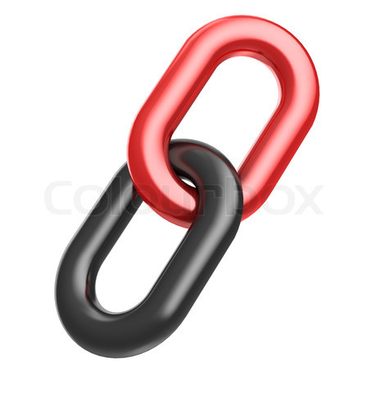

* Young designers
* Design Association
* Dyson designers

Each of the items below will link you to specific and appropriate learning materials, videos, curriculum links, podcasts for the above year and subject

DESIGN & INNOVATE

YEAR 6